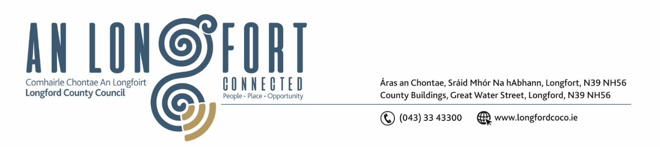

**LONGFORD MUNICIPAL DISTRICT**

***Please note meeting will be held in the Council Chamber, Aras an Chontae and via Microsoft Teams***

**20 March 2024**

**To: Each Member of Longford Municipal District.**

**Dear Member,**

You are requested to attend the Meeting of Longford Municipal District to be held in **the Council Chamber, Aras an Chontae** and **via Microsoft Teams** on **Wednesday 27 March 2024 at 4pm** to transact business, as set out on the agenda hereunder.

**Yours sincerely**,

_______________

**Claire McNabola**

**Meetings Administrator**

**AGENDA**

Prayer before meeting.

**1.** Confirmation of Minutes:

1. Longford Municipal District Meeting held on Wednesday 21 February 2024 – enclosed.
2. Longford Municipal District Committee Meeting held on Wednesday 21 February 2024 – enclosed.

**2.** Matters arising from Minutes.

**3.** Declaration of Interest by Members.

**4.** Management Report - enclosed

**5**. Presentation on Longford Purple Flag for the Night-time Economy

**6.** Taking in charge of the of the roads, footpaths and green areas in the Longford Business and Technology Park

**7.** Consideration of Schedule of Longford Municipal District Works – enclosed

**8.** Provision of a sensory area at the St Patricks Day Parade in Longford Town.

**9.** Notices of Motions, submitted by Councillors, as listed hereunder:

**Councillor Seamus Butler**

1. ‘That Abbeycartron Lane, all the way down to Brickfield, be included in our 2024 roads programme for repairs and resurfacing. The inadequate lighting also requires enhancement. The signage on the Battery Road should be revised to the new town finger posts listing all the estates branching off Abbeycartron Lane. As there are some unusual numbering systems in some estates here, there should be a rolling programme of house numbering signage like College Park and Templemichael Glebe.’

**Councillor Uruemu Adejinmi**

1. I call on Longford County Council to carry out a speed review on the L1171 Clondra road from the entrance close to Tarmonbarry down to the bridge. There is an 80km stretch and residents living along the road have complained about speeding
2. I call on Irish Water to extend the sewage system out to the homes with septic tanks on the L1171 Clondra Road.
3. I call on the National Transport Authority to introduce a bus route through Clondra to connect the village to other communities, schools, shops and improve connectivity to other Regional transport networks to facilitate onward travel to cities and colleges.